



Essay / Assignment Title:
Crisis-Response Conversational Agent for Emergency Information Management Using the Rasa Platform
Programme title:
Advanced Conversational UI Design and Chatbot Development
Name:
Mahla Almardani, Q1107537
Year: 2025

CONTENTS

Contents
CONTENTS 2
Introduction 4
Introductions 4
CHAPTER ONE 5
System Analysis and Requirements 5
CHAPTER TWO 8
Natural Language Understanding (NLU) 8
Domain, Slots, Forms, and Responses 9
CHAPTER THREE 14
Evaluation and Interpretation (Interactive Rasa Shell Run) 14
CHAPTER FOUR 17
Ethical Considerations & Limitations and Future Work 17
CONCLUDING REMARKS 19
Conclusion 19
BIBLIOGRAPHY 20
References 20
APPENDIX (if necessary) 21

Statement of compliance with academic ethics and the avoidance of plagiarism

I honestly declare that this dissertation is entirely my own work and none of its part has been copied from printed or electronic sources, translated from foreign sources and reproduced from essays of other researchers or students. Wherever I have been based on ideas or other people texts I clearly declare it through the good use of references following academic ethics.
(In the case that is proved that part of the essay does not constitute an original work, but a copy of an already published essay or from another source, the student will be expelled permanently from the program).

Name and Surname (Capital letters):

....................MAHLA ALIMARDANI..................................................................................................................

Date: ..............01.........../....31....../......2026...

Introduction

Introductions
Natural and artificial catastrophes like earthquakes, floods, fires, storms, building collapses among others usually take place without warning and affected people in very stressful environments. In these emergencies, individuals might develop panic, injury and moving around with limited mobility or difficulty receiving timely and reliable information. Meanwhile, emergency service can be overloaded, which will result in a delay in human support. All these issues indicate a necessity to use additional tools offering immediate, systematic, and safety-focused instructions.
Conversational agent has become a potential solution in offering real-time support in emergencies. In contrast to conventional predefined information systems, chatbots are capable of dynamically interacting with their users, responding to questions based on prior answers, and providing step-by-step instructions to users to critical decision-making processes. Nevertheless, assistants that operate on a general-purpose basis are not similar to crisis-response chatbots. They work in a safety-critical situation where a faulty recommendation, ambiguity, or overconfidence may cause severe damages. Thus, these systems should be more reliable, transparent, and ethical rather than flexible or creative (Amershi et al.,2019)
The project introduces a chatbot design and implementation of a crisis-response chatbot created on the conversational AI platform, Rasa which is an open-source platform. The chatbot is built based on a triage-first architecture, where an interaction sequence is guided by a form of multi-turn structure, helping gather a required amount of situational data. According to this information, the system conducts a deterministic and explainable risk evaluation, offers hazard-aware safety advice, and forwards high-risk cases to a human operator. The design clearly does not matter with speculative replies and focuses on the human-in-the-loop principles, as per the best practices in safety-critical AI systems (FEMA, n.d.; WHO, n.d.)
This assignment is a detailed analysis of the chatbot system, such as the requirements analysis, conversation design, natural language understanding (NLU) configuration, validation and normalization mechanisms, risk evaluation logic, escalation strategies, evaluation methodology, ethical concerns, limitations, and future work.

CHAPTER ONE

System Analysis and Requirements
- Problem Definition:
One of matters that a crisis-response chatbot should do is that handling noisy, short, emotional, and ambiguous such as, helping, smoking, my hand is broken, and so on. Also, avoiding misinformation and exaggeration are other factors that a chatbot must consider. Moreover, the chatbot must ask only questions that are necessary by using simple answers like Yes, No, minor, serious, and so on. As a result, if the risk of the result is high, the chatbot should be able to connect the user to a human operator.
There are several principles:
- Fast triage entry: A user can access triage through a fast system.
- Structured information collection: there are some basic questions that users are able to response them via the forms.
- normalization and validation: this part ensures that the inputs that a user gave are true or not.
- Deterministic, explainable risk assessment: there are a few predefined rules that determine whether the risk is high, low, or needs an emergency situation.
- Safe escalation: this means when a dangerous situation occurs, the chatbot no longer tries to give information or do something, it will convey all information about the user to a human so that they can make a precise decision.
- Robust fallback and out-of-scope handling: when a user inputs words or requests that are out of the chatbot’s ability, the chatbot will send a response that this is misunderstanding or it does not have enough information about this matter.

- Rule-Based Triage Initiation
Emergency conditions are introduced by rules, not based on the dialogues that exist between bot and users. This helps to reach a meticulous decision and ensure constant safety behavior.
  - . Requirement:
When a user reports an emergency situation or tries to get help, and presents a hazard directly, the chatbot has to start the triage.
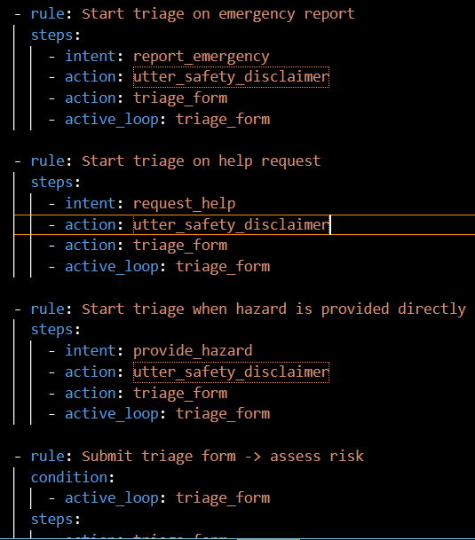
  - . Analysis:
This fulfils robust triage entry: a person can say I need help, there is an emergency or simply say earthquake. The safety warning is displayed at the point of triage entry, enhancing openness and minimizing damaging dependency. On the other hand, rules will mean that triage and risk examination will always follow the identification of an emergency. This is crucial in the case of crisis systems, as probabilistic dialogue choice could result in unsafe omissions.

- Story-Based Example Flows
The progression of conversations through time follows the established paths which storytelling and rule systems create. The dialogue model learns common interaction patterns through storytelling which shows dialogue paths from the beginning to the end of conversations although the rules maintain fixed responses in important moments. The crisis-response chatbot uses rules to manage all safety-critical operations which include triage start procedures and risk assessment processes and fallback event handling and human handover activation. The system guarantees that vital operations will occur at all times throughout the dialogue process. The stories show actual user paths which start with a greeting and end with a help request to enhance system performance while maintaining safety standards. Also, examples of dialogue paths are given in stories to serve as guides in training.
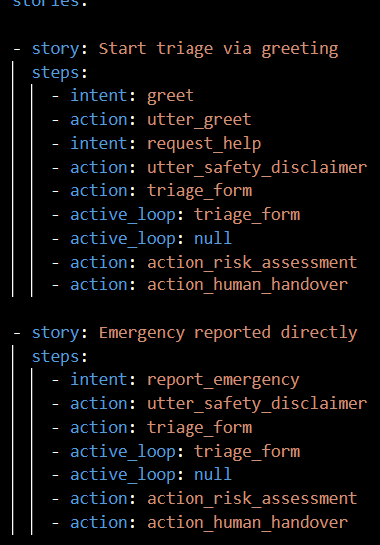

CHAPTER TWO

Natural Language Understanding (NLU)
- Intent and Entity Definitions
The NLU component is responsible for interpreting raw user input and converting it into structured representations that the dialogue manager can process. Specifically, the NLU model identifies the user’s intent, such as what the user wants to do, and extracts entities, key pieces of information such as location, hazard type, or injury level.
In this project, the NLU configuration is designed to handle short, noisy, and emotionally messages, which are common in crisis situations. Separate intents are defined for emergency initiation for instance, requesting help or reporting danger and for providing specific information during triage such as location, injury status, or trapped condition. This separation improves robustness and reduces misclassification during form-based data collection. Character-level features and fallback thresholds are used to mitigate the impact of spelling errors and ambiguous inputs.
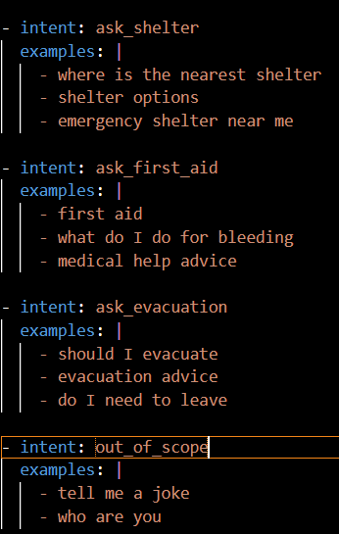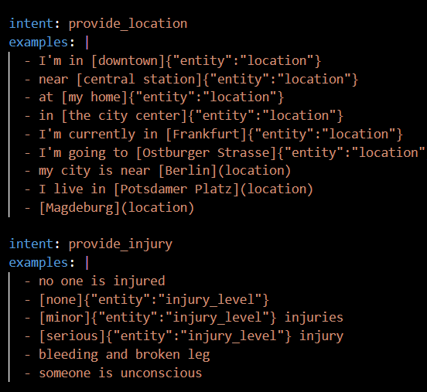
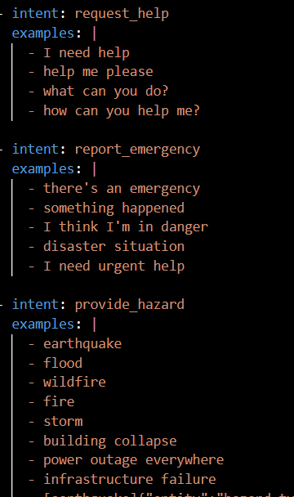
  - Analysis:
The NLU can detect emergency situations from slot intents and remain robust to noisy and incomplete inputs while improving maintainability(Amershi et al., 2019).

Domain, Slots, Forms, and Responses
- Domain
  - Requirement:
The system should execute the collection of required information through a multistep form-interface.
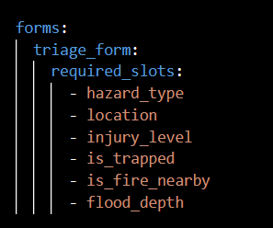
The domain file is the key schema of the chatbot. It establishes what is known and is capable of the system. This can includes:
- the list of supported intents and entities,
- the locations of extracted information,
- the reactions that the chatbot has ability,
- the templates of structured information gathering,
- the habitual actions that may be performed.
This project has the domain specifying a triage form which imposes the gathering of safety critical slots like type of hazard, place of hazard, level of injury and environmental hazards. Whether entity extraction is not perfect, Slot mappings are set up to receive user input in text form in the active form loop. The design enables the fact that subsequent validation and normalization can be addressed in a specific manner in the action server, enhancing safety and transparency.
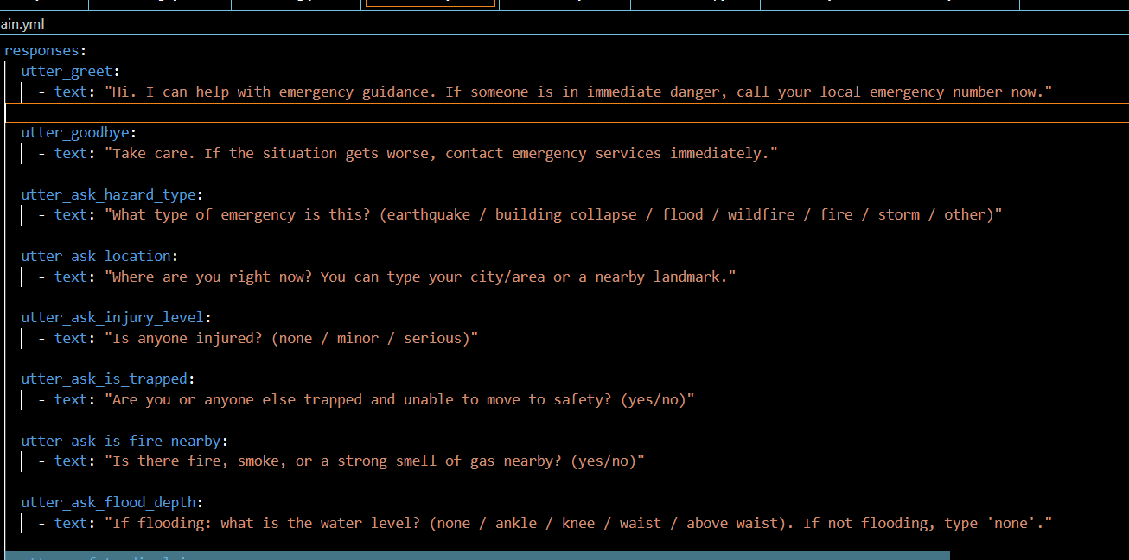
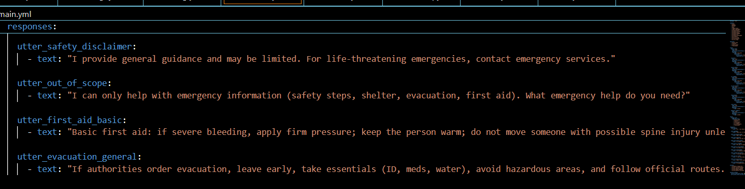
  - Analysis:
The safety-critical triage process requires forms which must be completed by users through specific field entries because the forms control their conversations. The design of your prompts provides brief and limited options which help users who need help.
- Actions:
Custom actions are used to take the chatbot further than some pre-defined responses. They are written in Vscode and are run using an action server (rasa). This project involves the use of custom actions in order to carry out tasks involving logic, validation or decision making.
Key custom actions include:
- checking form-data, for instance, normalized hazard types and yes or no responses.
- deterministic risk assessment with regards to gathered safety signals.
- creation of structured overviews to be transferred to human operators.
- managing fallback during the case of unclear user input.
The system ensures that there is a sharp distinction between the conversational flow and logic of safety decisions that are isolated by critical logic within custom actions. This modular structure enhances both maintainability, auditability and ethical accountability which are important characteristics of crisis-oriented conversational systems.
  - Requirement:
For the system becomes safe, the threat must define before and the bot act based on the definitions.
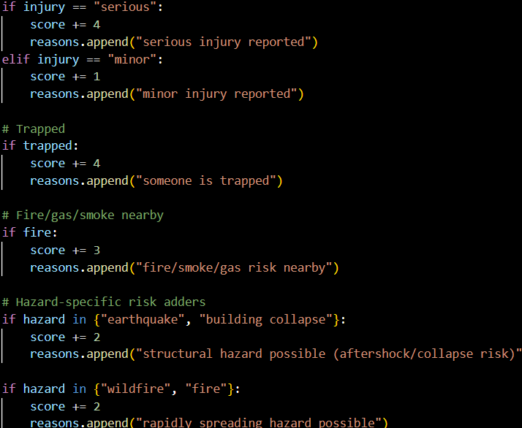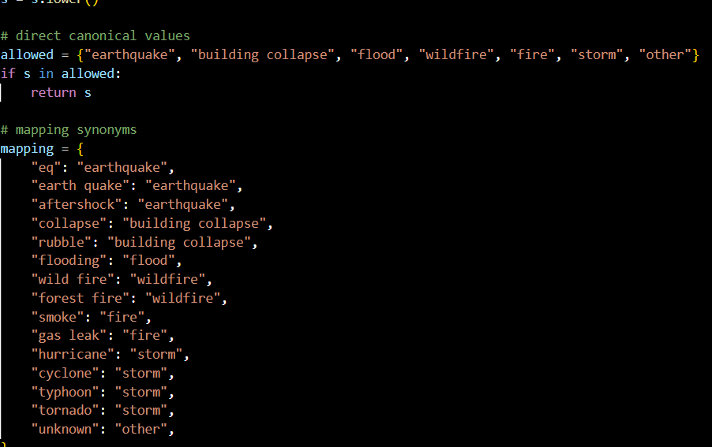
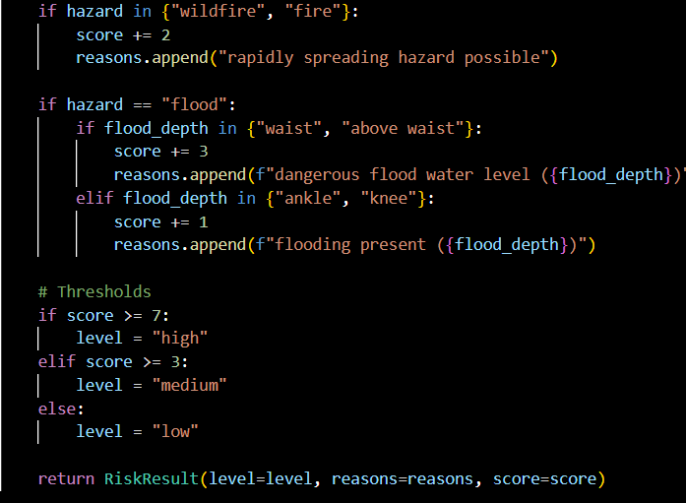
  - Analysis:
The design prevents users from interpreting hazards through uncontrolled free-text testing because it uses uncontrolled free-text testing which produces unregulated text results. The use of controlled labels in crisis systems helps to decrease the chances of providing unsafe recommendations. The action server performs four functions which include verification and data standardization and risk assessment through fixed methods and the transfer of control to human operators. The system uses rule-based scoring methods to achieve two goals which include providing clear explanations of its results and maintaining ethical standards of security.

CHAPTER THREE

Evaluation and Interpretation (Interactive Rasa Shell Run)
This section evaluates a live interactive session of crisis-response chatbot on Rasa Shell. The output demonstrates that the system is loaded, it is working on form-based triage, it is executing the validation and risk scoring, and it is able to generate structured human handover summary. Moreover, the log indicates a single configuration inconsistency (an entity defined in NLU, but not in the domain) that can be useful in enhancing reliability and maintainability.
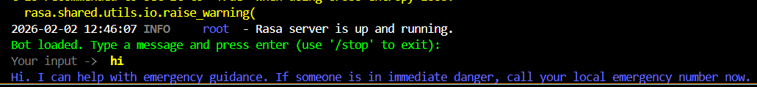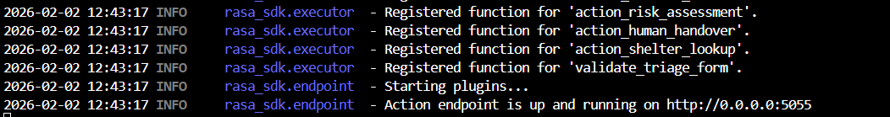
- Model loading and server readiness
This part of code shows that our model trained and was successfully located and loaded. Because if the model did not train well or was placed in an incorrect location, we would receive an error. The various elements in Rasa model archive are the NLU pipeline components such as tokenizer, featurizers, DIET classifier, and so on the dialogue policies (RulePolicy, TEDPolicy, MemoizationPolicy) and the domain configuration during training. The message contains the words Rasa server is up and running which refer to the fact that the runtime is available to accept user messages and make predictions. It is important to the evaluation because it will split the deployment problems like model not loading, server down and the problems with the conversation design for instance a wrong flow or wrong intent mapping.
- Training warning:
This warning is related to the DIETClassifier training setting constrain similarities is generally advised in case of cross-entropy loss because it may increase stability and minimize unwanted similarity learning among classes. Although my config is constrain-similarities= true, the warning indicates the model may train with a various setting like older model or the runtime loads another different config than what is. So, it doesn’t break functionality, but it can suggest the following matters:
- the model was trained before changing config.yml
- there are many different models that we did not use the newest one.
- There is a mismatch between configuration and the current file.

This senarius mean that it is important to my report: It proves that I evaluated a real ML system on which configuration consistency is significant. The aspects of reliability in safety-oriented chatbots are reproducibility and traceable training settings.

Improvement to be taken: retrain with the desired set up and verify with:
- rasa train
- then execute the new model out of models or remove older models in order to be no longer confused.

- Greeting flow and system scope setting
This part illustrates a noteworthy usability and safety pattern the system utilizes the greeting as not a casual talk, but as a capability and urgency framing message. It is an instant reminder to the user to call emergency services when they need help. This helps ensure ethical transparency and over-trust of automation by enabling the limitations of the system to be known ahead of time. Early framing can be used in crisis systems to make the chatbot less misunderstood in terms of authority and scope by users.
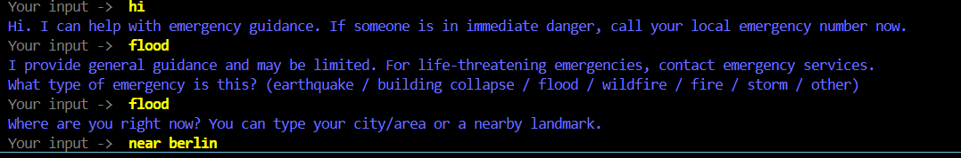

- Triggering triage and repeating hazard type question
This shows the triage trigger of the rule based working and the slot-filling order of form working in place:
- The initial flood is seen as an emergency entry, which is the triggering point of the triage flow.
- The bot presents utter safety disclaimer prior to data collection.
- The first slot required is hazard-type, and it is in the form.
On repeating the term flood, the user is accepted as the hazard type value and the form continues to the next slot that is location. This is a good example of the workings of forms with short inputs. Although the user may not answer the form with a complete sentence, the form will extract the required slots values. It also is quite resilient, the initial flood of the user was considered the trigger, the second flood was considered the slot answer, which is natural in a dialogue.
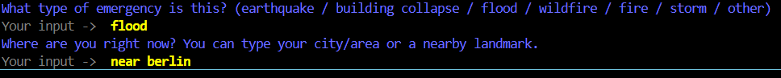

- Location
This part of code requires user’s location to know where the person is so that an operator can get better help the person. As we can observe, the user mentioned I am near Berlin, therefore the system accepts Berlin and uses it in guidance (in near Berlin). As a result, this confirm that the bot also supports descriptive location, which is necessary in emergency situations because the user may not know the precise address.
- Injury severity and entrapment: high-value safety signals
These slots are two essential weights in the risk scoring design, in other words, this section has a profound impact on the final decision. For example, if the user enters words like serious and entrapment, this means they needs immediate support or should be connected to a human operator. First, the bot evaluates all essential requirements and then the score is not high, it gives some recommendations, but if it is so, the bot connects him to a human operator. There are three formats including none, minor, and serious that not only reduce ambiguity between users and the bot but also help a fast user response, that is important, especially when the client is under pressure and stress.
- Flood depth
Since the type of hazard is a flood, the system asks to be flooded. This validates the triage that is hazard conscious. The depth of the flood is also important because greater depth of water will create a risk of drowning, exposure to contamination, and mobility risks, as well as may suggest a rapid increase. Flooding that is at the ankle level is not a trivial risk signal even when used together with other variables such as injury or trapped.

- Risk classification result and why it became HIGH
the last risk level is high, and the summary is structured in explaining it. This is just what we desire in a safety-critical system a traceable decision.
The score of 9 matches logic of scoring:

serious injury = +4
trapped = +4
flood depth ankle = +1
Total = 9 -> threshold for High is >= 7 -> HIGH

It proves that the risk scoring is consistent and explicable. It also shows a conservative position of safety, despite the fact that the depth of the flood is no more than ankle, serious injury and entrapment are enough to be considered as high risk area.

- Human operator escalation and context preservation

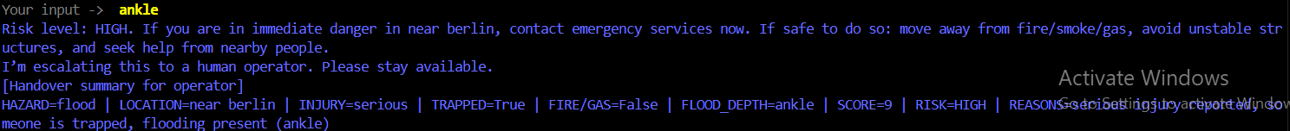

This proves the operationally installed requirement of the human-in-the-loop. In practice, such a handover summary would be sent to an operator system instead of displayed to a user nevertheless, in the case of an academic prototype, it is reasonable to print the summary, and that would be considered a demonstration of preserved context and system transparency. Importantly, the summary format is concise and formatted, and it is therefore easy to scan operators when there is high workload, a requisite that is critical in such situations. Therefore, our output facilitates transparency and confidence of the user in safety-critical situations, the system has interpretable outputs and explanations to its risk assessment decisions (Gunning and Aha, 2020).

- Graceful termination
This part is finished by a reminder on safety. It is a pattern of little but good use. The system promotes the escalation to the emergency services in case of the further aggravation of the situation, which strengthens the responsible leadership even in the end of the dialogue.

CHAPTER FOUR

Ethical Considerations & Limitations and Future Work
- Ethical Considerations
The ethical artificial intelligence is followed by the system in a sequence of strictly determined mechanisms of operation. These consist of explicit safety disclaimers used to handle the expectations of users, organized and open-minded decision-making processes, the incorporation of human control to manage difficult situations, and an information gathering policy. A combination of these mechanisms is used to provide responsible system behaviour within safety-critical emergency situations)WHO, n.d. & UNESCO, 2021)

- Limitations
- The small amounts of NLU training data can have an impact on the adaptability of a system when it is deployed in the real world. Shelter lookup functionality is not connected to real-time databases.
- The appropriate score acts to make obscure real-life dynamics less enigmatic.
- The handover between robots not being very combined.

- Future Work

- The organization needs to increase its training data and multilingual capabilities.

- It needs to establish connections with official emergency services and shelter systems through API integration.Integrate official emergency and shelter APIs.

- It is necessary to establish connections with official emergency services and shelter systems through API integration.
- The system requires operators to have access to secure platforms which include logging functions.

CONCLUDING REMARKS

Conclusion
The project develops a crisis-response chatbot which Rasa uses to implement its triage-first conversation method. The system implements rule-based triggers to begin triage operations which use a form to collect organized safety data and validate user inputs through three processes that include risk assessment which leads to a complete handover of high-risk cases to human operators. The system design achieves its goals of maintaining safety which requires minimal mental effort and complete system transparency and system resilience through its fallback handling system. The existing prototype establishes basic capabilities for emergency shelter systems together with natural language understanding capabilities which create a foundation for building better secure systems that support crisis-related conversational systems. Future enhancements will lead to three main improvements which involve connecting emergency data sources that provide real-time information and developing support for multiple languages and creating better risk assessment methods which will help organizations handle unpredictable emergency situations.

BIBLIOGRAPHY

References
- Amershi, S., Weld, D., Vorvoreanu, M., Fourney, A., Nushi, B., Collisson, P., Suh, J., Iqbal, S., Bennett, P., Inkpen, K., Teevan, J., Kikin-Gil, R. and Horvitz, E. (2019) Guidelines for Human-AI Interaction. Proceedings of the 2019 CHI Conference on Human Factors in Computing Systems.
- Federal Emergency Management Agency (FEMA) (n.d.) Emergency preparedness and response guidance. Available at: https://www.fema.gov (Accessed: 31 January 2026).
- World Health Organization (WHO) (2021) Ethics and governance of artificial intelligence for health. Geneva: WHO. Available at: https://www.who.int/publications/i/item/9789240029200 (Accessed:31 January 2026).
- Gunning, D. & Aha,D. (2019) Explainable artificial intelligence (XAI) Program. AI Magazine, 40(2), pp.44–58. Available at: DARPA’s Explainable Artificial Intelligence (XAI) Program | AI Magazine (Accessed: 2 Februery 2026).
- UNESCO (2022) Recommendation on the ethics of artificial intelligence. Paris: UNESCO. Available at: httpshttps://www.unesco.org/en/artificial-intelligence/recommendation-ethics (Accessed: 31 January 2026).

APPENDIX (if necessary)

You can find the related code at the following link.
https://github.com/mahlaalimardani/13711371

